PRE-REQISITES

IBM Cloud Services

|  |  |
| --- | --- |
| Date | 16 Nov 2022 |
| Team ID | PNT2022TMID42730 |
| Project Name | Industry specific intelligent fire management system |
| Maximum Mark | 2 |

Cloud services:

It is basically used to handle the cloud storage and data functions carried out in the system technology

IBM Cloud Service:

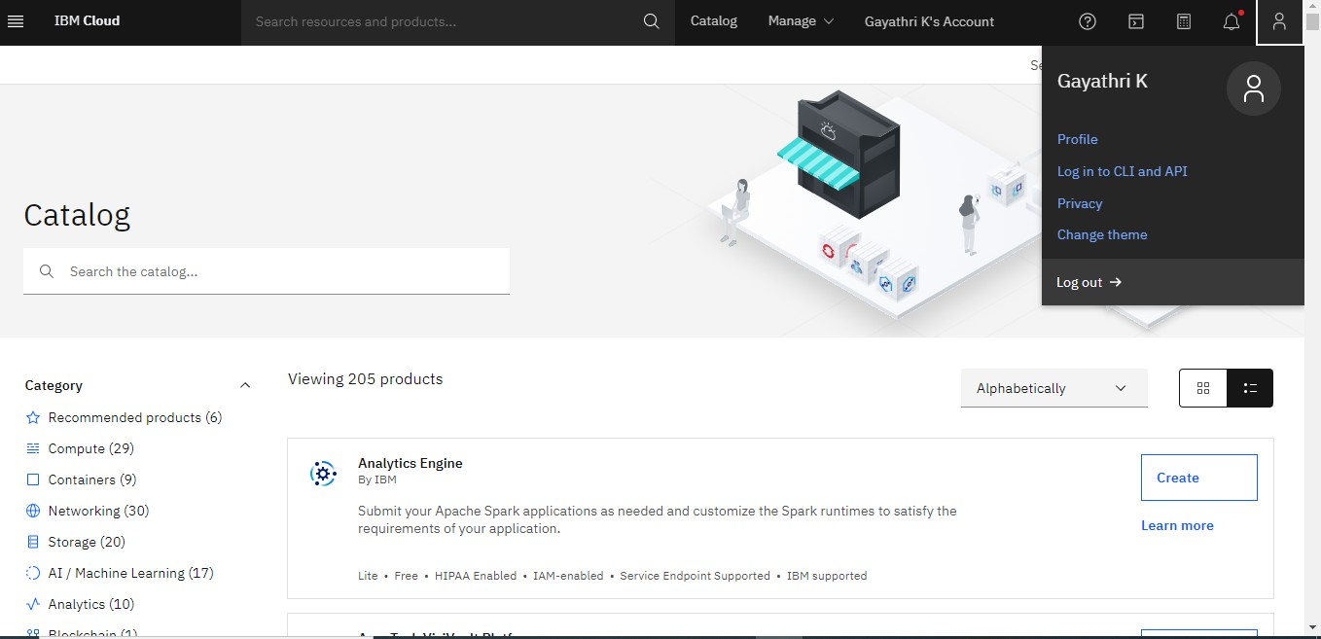

LAUNCH THE CLOUD TO GET……

